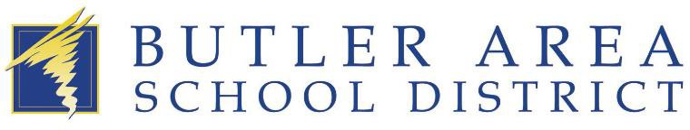

Enrollment for our new One-to-One device protection program is open!

Butler Area School District is partnering with One2One Risk Solutions to provide accident and loss protection for our school district’s one to one program. Registering with One2One and purchasing a damage waiver will protect you from the full cost to repair or replace your district- issued device and limit your responsibility to a per-occurrence deductible, should a loss occur.

Please visit www.one2onerisk.com and select “Enroll My Device” to get started.

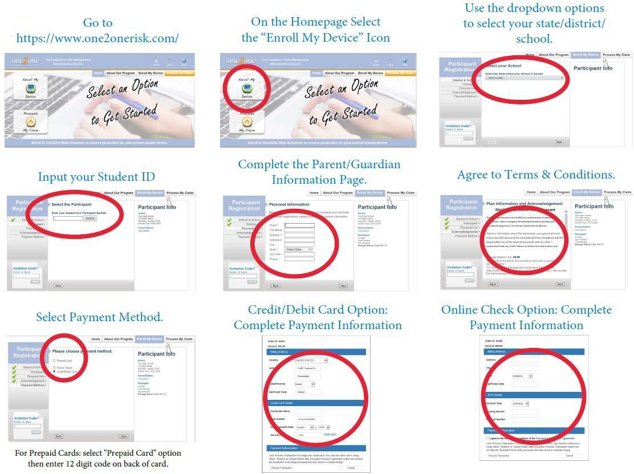

For questions or assistance about the program, contact:
Heather Bonzo | BASD Business Manager | heather_bonzo@butler.k12.pa.us | 724-214-3140

