EMPLOYEE INFORMATION
Employee Name (Last, First, MI) | Position/Location

Financial Institution Information
Your direct deposit may be split between two account numbers in the same institution or between two financial institutions if you desire. Please provide the information below for up to two financial institutions.
Financial Institution #1:
Account Type: | ☐ Checking | ☐ Savings
Account Number:
Routing Number:
Amount to be Deposited: | ☐ Fixed Amount: | ☐ Entire Net Amount
Financial Institution #2:
Account Type: | ☐ Checking | ☐ Savings
Account Number:
Routing Number:
Amount to be Deposited: | ☐ Fixed Amount: | ☐ Entire Net Amount
Please include a copy of a voided check

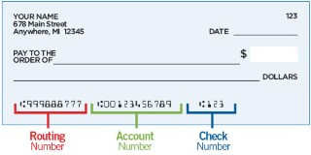
I hereby authorize the Butler Area School District, hereinafter referred to as employer, to direct the amount of my periodic pay for crediting to my account(s) indicated at the financial institution(s) designated above, and I further authorize the financial institution(s) to credit the same to such account(s) without responsibility for correctness of such amount.

This authorization will remain in effect until I initiate the required stop action in such time and in such manner as to allow my employer a reasonable opportunity to act upon it. Furthermore, I understand that termination of employment with my employer shall constitute sufficient authorization to terminate this agreement.

I agree to notify my employer if I wish to change the designated financial institution(s) or account(s) to which my pay is to be deposited 30 days prior to the effective date of such change. I understand that failure to do so may delay the receipt of my pay.

