Butler County Parent Transition Group
www.butlercountypatransition.org

Friday, October 19, 2018
12:00 – 1:30 PM

Speaker: Marissa Wagner

Special Projects Coordinator

The Arc of Butler County

Topic: The AERO Program
(Abilities Enrichment and Readiness Opportunities)
AERO is an after-school program to assist students with disabilities transition in life following high school.

The Arc of Butler County – Board Room
112 Hollywood Drive, Suite 202, Butler PA 16001
Register no later than October 15th
Betsy Rideout 724-991-0623, or
Diane Reep 724-282-1500 ext. 1005 or dreep@arcbutler.org

A light lunch will be served.

The Butler County Parent Transition Group is a group of parents and professionals who offer guidance and support to parents of students with disabilities who are making the transition from high school to post-secondary education, employment, and community living.
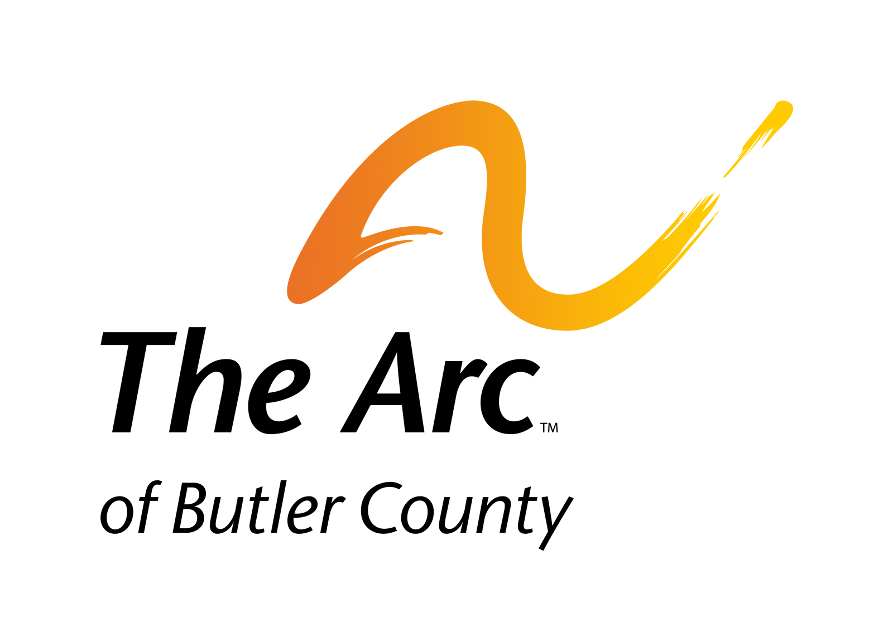

PTG is sponsored by The Arc of Butler County www.arcbutler.org

